Name: Areeba Saleem

Roll number 2k21/MKIT/03

Information Technology

(Part 2)

Assignment Number 1

Of python programming

Given by: Sir Muhammad hanif

Task 1:

for i in range(48):

if i == 3:

break

print (i)

print(“is your roll number”)

output

1

2

3

Is your roll number

Snapshot

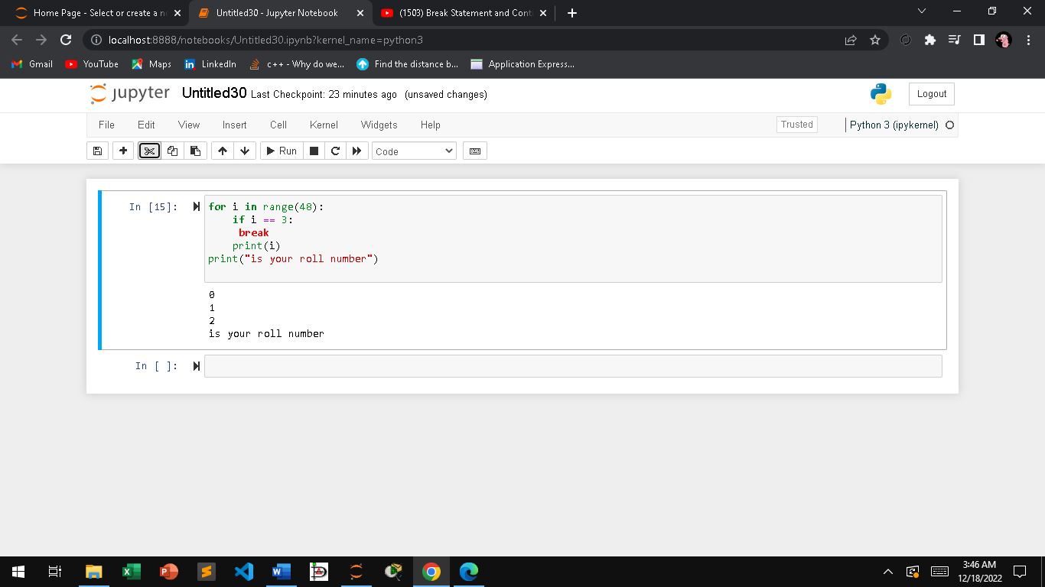

Task 2:

for x in range(1,48):

if (x%5) ==0:

continue

print(x)

output

1

2

3

4

6

7

8

9

11

12

13

14

16

17

18

19

21

22

23

24

26

27

28

29

31

32

33

34

36

37

38

39

41

42

43

44

46

47

Snapshot

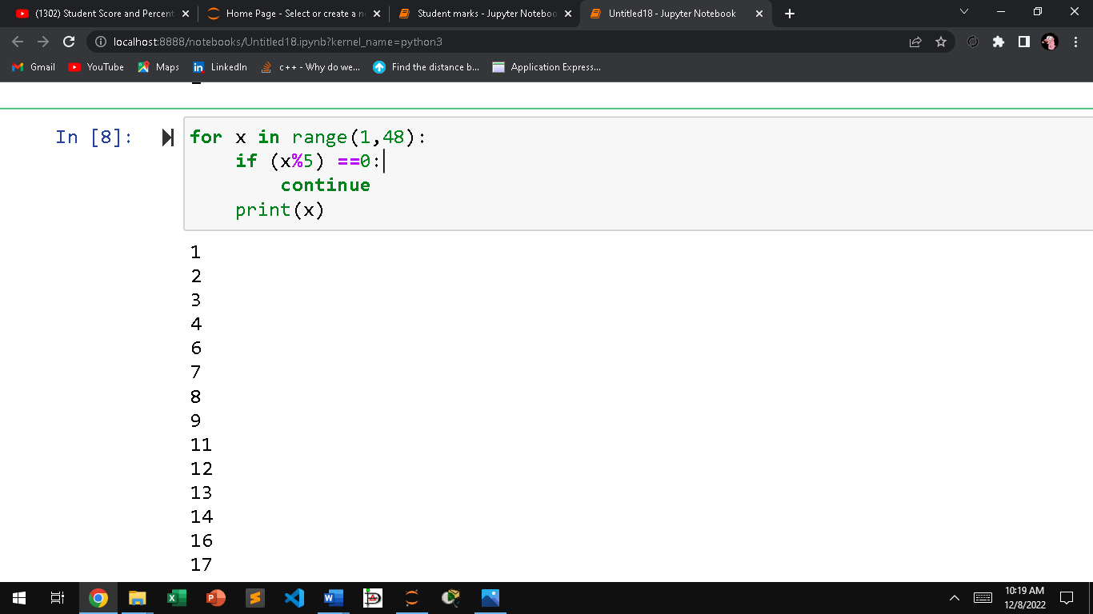

Task 3:

code

sub1 = int(input("Data stucture:"))

sub2 = int(input("linear algebra:"))

sub3 = int(input("Micro pro:"))

sub4 = int(input("TRW:"))

sub5 = int(input("Pak study:"))

sub6 = int(input("Software engineering:"))

print()

total = sub1+sub2+sub3+sub4+sub5+sub6

print ("Total Score:" ,total)

percentage = (total/600)\*100

print("Percentage:", percentage, "%")

Output

Data stucture:87

linear algebra:90

Micro pro:90

TRW:87

Pak study:84

Software engineering:87

Total Score: 525

Percentage: 87.5 %

Snapshot

